**Entrepreneurs vs Managers**

**Who is an Entrepreneur?**

Very basically speaking, an entrepreneur is a one-man show that runs entrepreneurship. However, such a person usually has some unique attributes that allow him to be successful in his endeavors. He is essentially an initiator and a leader. He brings business ideas to fruition thus starting off his venture.

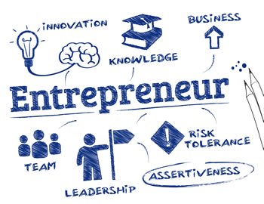

A successful entrepreneur is usually a responsible person. He is accountable for the success or the failure of his venture, and he takes this responsibility very seriously. And since he is the only person in-charge he is automatically the leader. In fact, [leadership](https://www.toppr.com/guides/business-management-and-entrepreneurship/direction-and-coordination/elements-of-direction-leadership/) qualities are one of the main aspects of an entrepreneur.

**Who is a Manager?**

A manager, on the other hand, is not an owner of an enterprise. Instead, he is the one that is responsible for the management and administration of a group of people or a department of the organization. His day to day job is to manage his employees and ensure the organization runs smoothly.

A manager must possess some of the same qualities as an entrepreneur, like leadership, [accountability](https://dictionary.cambridge.org/dictionary/english/accountability), decisiveness etc. He must also be a good manager of people. So qualities such as warmth and empathy are also very important in a manager.

Now that we have a brief idea about their qualities and roles, let us take a look at the difference between them

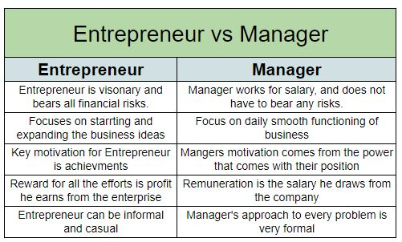

**Difference between Entrepreneur and Manager**

* The key **difference between an entrepreneur and a manager** is their standing in the company. An entrepreneur is a visionary that converts an idea into a business. He is the owner of the business, so he bears all the financial and other risks. A manager, on the other hand, is an employee, he works for a salary. So he does not have to bear any risks.
* The focus of an entrepreneur lies in starting the business and later expanding the business. A manager will focus on the daily smooth functioning of the business.
* For an entrepreneur the key motivation is achievements. But for the managers, the motivation comes from the power that comes with their position.
* The reward for all the efforts of an entrepreneur is the profit he earns from the enterprise. The manager is an employee, so his remuneration is the salary he draws from the company.
* The entrepreneur can be informal and casual in his role. However, a manager’s approach to every problem is very formal.
* The entrepreneur by nature is a risk taker. His has to take calculated risks to drive the company further. A manager, on the other hand, is risk-averse. His job is to maintain the status quo of the company. So he cannot afford risks.

Key Differences Between Entrepreneur and Manager

The difference between entrepreneur and manager can be drawn clearly on the following grounds:

* A person who creates an enterprise, by taking a financial risk in order to get profit, is called an entrepreneur. An individual who takes the responsibility of controlling and administering the organisation is known as a manager.
* An entrepreneur focuses on business startup whereas the main focus of a manager is to manage ongoing operations.
* Achievements work as a motivation for entrepreneurs. On the other hand, the primary motivation is the power.
* The manager’s approach to the task is formal which is just opposite of an entrepreneur.
* An entrepreneur is the owner of the enterprise while a manager is just an employee of the company.
* A manager gets salary as remuneration for the work performed by him. Conversely, profit is the reward for the entrepreneur.
* An entrepreneur’s decisions are driven by inductive logic, courage, and determination; that is why the decision making is intuitive. On the contrary, the decision making of a manager is calculative, as they are driven by deductive logic, the collection of information and advice.
* The major driving force of an entrepreneur is creativity and innovation. As against this, a manager maintains the existing state of affairs.
* While entrepreneur is a risk taker, the manager is risk averse.

Conclusion

After reviewing the above points, it is quite clear that entrepreneur and manager are two different persons in an organisation. So they cannot be juxtaposed. While managers concerned with managing available resources, entrepreneur focuses on spotting and capitalising opportunities